**Karan Arora**  **R.L. Institute M: 9416974837**

**Max Time : 1 hr** **Class = 12th Chemistry Test Max Marks : 50**

**Biomolecules**

1. Which of the following reaction confirms the presence of carbonyl group (>C = O) in glucose?

|  |  |
| --- | --- |
| a) Reaction with HI | b) Reaction with hydroxylamine |
| c) Reaction with HCN | d) Both (b) & (c) |

1. Cellulose is not digestible by human beings due to absence of cellulose hydrolyzing enzyme called :

|  |  |  |  |
| --- | --- | --- | --- |
| a) Cellulase | b) Invertase | c) Zymase | d) Urease |

1. Which of the following polymer is stored in the liver of animals?

|  |  |  |  |
| --- | --- | --- | --- |
| a) Amylose | b) Cellulose | c) Amylopectin | d) Glycogen |

1. Which of the following naturally occurring $α$– amino acids is optically inactive?

|  |  |  |  |
| --- | --- | --- | --- |
| a) Glycine | b) Alanine | c) Leucine | d) Valine |

1. The reaction of concentrated sulphuric acid with carbohydrates (C12H22O11) is an example of :

|  |  |  |  |
| --- | --- | --- | --- |
| a) Dehydration | b) Oxidation | c) Reduction | d) Sulphonation |

1. Which of the following statement is not true about glucose?

|  |  |
| --- | --- |
| a) It is an aldohexose | b) It contains five hydroxyl groups |
| c) It is a reducing sugar | d) It is an aldopentose |

1. Which of the following is a basic amino acid?

|  |  |  |  |
| --- | --- | --- | --- |
| a) Alanine | b) Tyrosine | c) Lysine | d) Serine |

1. The non-essential amino acid among the following is :

|  |  |  |  |
| --- | --- | --- | --- |
| a) Leucine | b) Alanine | c) Lysine | d) Valine |

1. Which of the following compounds can form a Zwitter ion?

|  |  |  |  |
| --- | --- | --- | --- |
| a) Benzoic acid | b) Acetanilide | c) Aniline | d) Glycine |

1. In a protein molecule various amino acids are linked together by :

|  |  |  |  |
| --- | --- | --- | --- |
| a) $β$– glycosidic bond | b) Peptide bond | c) Dative bond | d) $α$– glycosidic bond |

1. Which one give below is a non-reducing sugar?

|  |  |  |  |
| --- | --- | --- | --- |
| a) Lactose | b) Glucose | c) Sucrose | d) Maltose |

1. D -(+)-glucose reacts with hydroxyl amine and yields an oxime. The structure of the oxime would be

|  |  |  |  |
| --- | --- | --- | --- |
| a) | b) | c) | d) |

1. Which one of the following sets of monosaccharides forms sucrose?

|  |  |
| --- | --- |
| a) $α$ D galactopyranose and $α$ D glucopyranose | b) $α$ D glucopyranose and $β$ D fructofrunanose |
| c) $β$ D glucopyranose and $α$ D fructofrunanose | d) $α$ D glucopyranose and $β$ D fructopyranose |

1. Which of the following does not exhibit the phenomenon of muta rotation?

|  |  |  |  |
| --- | --- | --- | --- |
| a) (+) Sucrose | b) (+) Lactose | c) (+) maltose | d) (–) Fructose |

1. The helical structure of protein is stabilized by :

|  |  |  |  |
| --- | --- | --- | --- |
| a) Dipeptide bonds | b) Hydrogen bonds | c) Ether bonds | d) Peptide bonds |

1. Which one of the following statements is not true regarding (+) lactose?
2. (+) lactose is a $β$– glycoside formed by the union of a molecule of D (+) glucose and a molecule of D (+) galactose
3. (+) lactose is a reducing sugar and does not exhibit muta rotation
4. (+) lactose, C12H22O11 contains 8 O – H groups
5. On hydrolysis (+) lactose gives equal amount of D (+) glucose and D (+) galactose
6. Number of chiral carbon atoms in $β$ D (+) glucose is :

|  |  |  |  |
| --- | --- | --- | --- |
| a) 5 | b) 6 | c) 3 | d) 4 |

1. The hormone that helps in the conversion of glucose to glycogen is :

|  |  |  |  |
| --- | --- | --- | --- |
| a) Cortisone | b) Bile acids | c) Adrenaline | d) Insulin |

1. Which one of the following gives positive Fehling’s solution test?

|  |  |  |  |
| --- | --- | --- | --- |
| a) Sucrose | b) Glucose | c) Fats | d) Protein |

1. $α$ D (+) glucose and $β$ D (+) glucose are

|  |  |  |  |
| --- | --- | --- | --- |
| a) Anomers | b) Epimers | c) Enantiomers | d) Geometrical isomers |

1. Glucose molecule react with X number of molecules of phenyl hydrazine to yield osazone. The value of ‘X’ is :

|  |  |  |  |
| --- | --- | --- | --- |
| a) 4 | b) 1 | c) 2 | d) 3 |

1. Sucrose in water is dextrorotatory, []D = + 66.4˚ when boiled with dilute HCl, the solution becomes levorotatory, []D = – 39.9˚. In this process sucrose breaks into:

|  |  |
| --- | --- |
| a) L – glucose + D – Fructose | b) L – glucose + L – Fructose |
| c) D – glucose + D – Fructose | d) D – glucose + L – Fructose |

1. On hydrolysis of starch, we finally get :

|  |  |  |  |
| --- | --- | --- | --- |
| a) Glucose | b) Fructose | c) Both (a) & (b) | d) Sucrose |

1. Which of the following is a pentose sugar?

|  |  |  |  |
| --- | --- | --- | --- |
| a) Ribose | b) Glucose | c) Fructose | d) Galactose |

1. Glucose does not react with :

|  |  |  |  |
| --- | --- | --- | --- |
| a) Br2/H2O | b) NH2OH | c) (CH3CO)2CO | d) NaHSO3 |

1. The incorrect statement regarding enzymes is :

a) Like chemical catalysts enzymes reduce the activation energy of bio processes.

b) Enzymes are polysaccharides.

c) Enzymes are very specific for a particular reaction and substrate.

d) Enzymes are biocatalysts.

1. Deficiency of which vitamin cause osteomalacia?

|  |  |  |  |
| --- | --- | --- | --- |
| a) vitamin A | b) vitamin D | c) vitamin E | d) vitamin K |

1. Which of the following statements is not correct?

a) Insulin maintains sugar level in the blood of human body

b) Ovalbumin is a simple food reserve in egg white

c) Blood proteins thrombin and fibrinogens are involved in blood clotting

d) Denaturation makes the proteins more active

1. The correct statement regarding RNA and DNA respectively is:

a) The sugar component in RNA is ribose and the sugar component in DNA is 2-deoxy ribose

b) The sugar component in RNA is arabinose and the sugar component in DNA is ribose

c) The sugar component in RNA is 2-deoxy ribose and the sugar component in DNA is arabinose

d) The sugar component in RNA is arabinose and the sugar component in DNA is 2-deoxy ribose

1. The central dogma of molecular genetics states that the genetic information flows from

|  |  |
| --- | --- |
| a) amino acids $→$ proteins $→$ DNA | b) DNA $→$ carbohydrates $→$ proteins |
| c) DNA $→$ RNA $→$ proteins | d) DNA $→$ RNA $→$ carbohydrates |

1. The correct corresponding order of names of four aldoses with configuration given below:

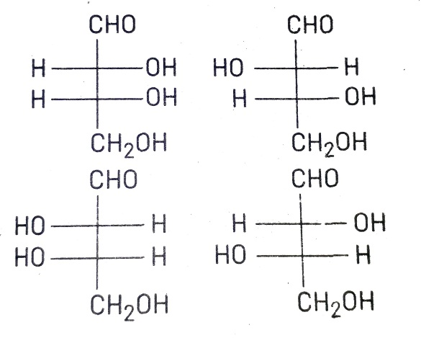 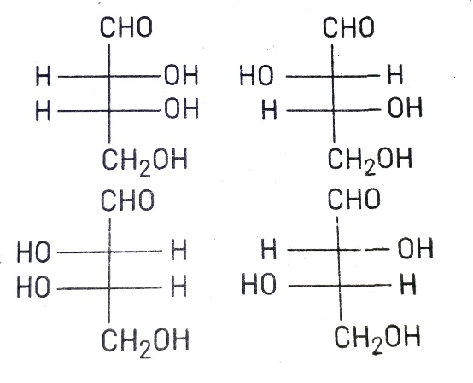

|  |  |
| --- | --- |
| a) L-erythrose, L-threose, L-erythrose, D-threose | b) D-threose, D-erythrose, L-threose, L-erythrose |
| c) L-erythrose, L-threose, D-erythrose, D-threose | d) D-erythrose, D-threose, L-erythrose, L-threose |

1. Which of the following hormones is produced under the condition of stress which stimulates glycogenolysis in the liver of human beings?

|  |  |  |  |
| --- | --- | --- | --- |
| a) Thyroxine | b) Insulin | c) Adrenaline | d) Estradiol |

1. Which of the following hormones contains iodine?

|  |  |  |  |
| --- | --- | --- | --- |
| a) Insulin | b) Testosterone | c) Adrenaline | d) Thyroxine |

1. The segment of DNA which acts as the instrumental manual for the synthesis of the protein is :

|  |  |  |  |
| --- | --- | --- | --- |
| a) Nucleotide | b) Ribose | c) Gene | d) nucleoside |

1. RNA and DNA are chiral molecules, their chirality is due to :

|  |  |
| --- | --- |
| a) L-sugar component | b) Chiral bases |
| c) chiral phosphate ester units | d) D-sugar component |

1. Which one of the following vitamins is water soluble?

|  |  |  |  |
| --- | --- | --- | --- |
| a) Vitamin – B | b) Vitamin – E | c) Vitamin – K | d) Vitamin – A |

1. The human body does not produce:

|  |  |  |  |
| --- | --- | --- | --- |
| a) DNA | b) vitamins | c) hormones | d) enzymes |

1. Vitamins B12 contains:

|  |  |  |  |
| --- | --- | --- | --- |
| a) Zn (II) | b) Ca (II) | c) Fe (II) | d) Co (III) |

1. Enzymes are made up of :

|  |  |
| --- | --- |
| a) edible proteins | b) Proteins with specific structure |
| c) Nitrogen containing carbohydrates | d) Carbohydrates |

1. Which statement is incorrect about peptide bond 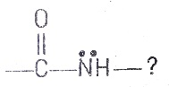

a) C – N bond length in protein is longer than usual bond length of C – N bond

b) Spectroscopic analysis show planar structure of group

c) C – N bond length in protein is smaller than usual bond length of C – N bond

d) None of the above

1. Chargaff’s rule states that in an organism

a) Amount of adenine is equal to that of cytosine and the amount of thymine is equal to that of guanine

b) Amount of all bases are equal

c) Amount of adenine is equal to that of thymine and the amount of guanine is equal to that of cytosine

d) Amount of adenine is equal to that of guanine and the amount of thymine is equal to that of cytosine

1. Which one of the following has magnesium ?

|  |  |  |  |
| --- | --- | --- | --- |
| a) Vitamin B12 | b) Chlorophyll | c) Haemocyanin | d) Carbonic |

1. Which one of the following is the sweetest sugar?

|  |  |  |  |
| --- | --- | --- | --- |
| a) Sucrose | b) glucose | c) Fructose | d) Maltose |

1. In DNA, the complementary bases are :

|  |  |
| --- | --- |
| a) adenine and thymine , guanine and cytosine | b) uracil and adenine , cytosine and guanine |
| c) adenine and guanine , thymine and cytosine | d) adenine and thymine , guanine and uracil |

1. Haemoglobin is :

|  |  |  |  |
| --- | --- | --- | --- |
| a) an enzyme | b) a globular protein | c) a vitamin | d) a carbohydrate |

1. The function of enzyme in the living system is to :

|  |  |
| --- | --- |
| a) transport oxygen | b) provide immunity |
| c) catalyze biochemical reactions | d) provide energy |

1. Which of the following protein destroy the antigen when it enters in body cell?

|  |  |  |  |
| --- | --- | --- | --- |
| a) Antibiotics | b) insulin | c) Chromoprotein | d) Phosphoprotein |

1. The $α-$ D-glucose and $β$-D-glucose different from each other due to difference in carbon atom with respect to its:

|  |  |
| --- | --- |
| a) Conformation | b) Configuration |
| c) number of OH group | d) size of hemiacetal ring |

1. Chemically considering digestion is basically

|  |  |  |  |
| --- | --- | --- | --- |
| a) Anabolism | b) hydrogenation | c) Hydrolysis | d) dehydrogenation |

1. The couplings between base units of DNA is through

|  |  |  |  |
| --- | --- | --- | --- |
| a) Hydrogen bonding | b) Electrostatic bonding | c) Covalent bonding | d) Vander wall forces |

**Answers [CLASS = 12th ]**

**Biomolecules**

|  |
| --- |
| 1. d |
| 1. a |
| 1. d |
| 1. a |
| 1. a |
| 1. d |
| 1. c |
| 1. b |
| 1. d |
| 1. b |
| 1. c |
| 1. d |
| 1. b |
| 1. a |
| 1. b |
| 1. b |
| 1. a |
| 1. d |
| 1. b |
| 1. a |
| 1. d |
| 1. c |
| 1. a |
| 1. a |
| 1. d |

|  |
| --- |
| 1. b |
| 1. b |
| 1. d |
| 1. a |
| 1. c |
| 1. d |
| 1. c |
| 1. d |
| 1. c |
| 1. d |
| 1. a |
| 1. b |
| 1. d |
| 1. b |
| 1. c |
| 1. c |
| 1. b |
| 1. c |
| 1. a |
| 1. b |
| 1. c |
| 1. a |
| 1. b |
| 1. c |
| 1. a |